University of Waterloo
Faculty of Engineering

Final Robotics Design Report

LU Robotics Incorporated.
Waterloo, Ontario

Prepared by
ID: 20302048
1A Mechatronics Engineering
Group: B

149 Halterwood Circle
Markham, Ontario L3P7T2

Professor S. Bedi
Director of Mechatronics
University of Waterloo
200 University Avenue West
Waterloo ON N2L 3G1

November 28, 2008

Dear Professor Bedi:
I have tailored the enclosed report, “Final Robotics Design Report”, as my work report for LU Robotics. The objective of this report is to analyze the design process and explain major components for the autonomous robot project.
As the team leader, my contribution to the project involves the major construction of the robot, algorithm debugging, Lego CAD drawings and the process of testing every design on the obstacle course.
This report, written entirely by me, has not received any previous academic credit at this or any other institution. I have not examined another individual’s report, either electronically or in hard copy. The entire report was produced by own efforts, with the exception of the NQC code. I would like to acknowledge the help of Mr. Calvin Kwan, a friend, who proofread my final report.

Sincerely,

20302048
LU Robotics Incorporated

Table of Contents

List of Figures and Tables iv
Summary v
1.0 Introduction 1
2.0 Mechanical Design 1
3.0 Software Design 3
4.0 Commissioning and Testing 4
4.1 Firmware Test 4
4.2 Mechanical Component Test 5
4.3 Movement Test 6
4.4 Sensor Tests 6
5.0 Project Management 7
6.0 Assembly and Operation 8
6.1 Mechanical Assembly Instructions 8
6.2 Software Details 9
7.0 Conclusions 9
8.0 Recommendations 9
Appendix A 11

List of Figures and Tables
Figure 1: Overall Structure of Final Robot Design 2
Figure 2: Robotics Project Gantt chart for 2008 7
Figure 3: Base Structure and Gear System 8
Table 1: Number of Successes and Failures for Various Motor Speeds 5
Table 2: Touch Sensor Testing Data 6

Summary
The objective of this report is to outline the design process, mechanical testing, code debugging, and the method of implementing the final solution for the robot designed by LU Robotics Incorporated. The robot must follow the obstacle course and finish in the fastest time without falling off the edge of the course. Therefore, completing the objective requires a balance of the robot’s speed and control while maintaining power and stability.
A definite integration between mechanical design and software architecture is critical for the overall performance of the robot. In addition, the overall structure of the robot, weight distribution and stability are vital considerations for the mechanical design. Another challenge for the mechanical design is the placement of the touch and light sensors. In final design, the team decided to place the light sensor on the right side of the robot, while creating two distinct mechanical parts to push the two different blocks where the touch sensor is connected to the upper part. The software design is straightforward and efficient, which allocates time for debugging and test runs. However, the characteristics of the obstacle course will change the effectiveness of the design. The robot uses the light sensor to distinguish the track and follows the inner loop of the obstacle course. After crossing the moat, the touch sensor will initiate when the robot reaches the final block. Then, the robot will finish execution after pushing the block off the course. Furthermore, the testing procedures that verify the various designs include testing the robot’s movement, sensor values, structure and efficiency.
On the day of evaluation, the motors failed to spin at coherent speeds. This resulted in the failure to push the block into the moat. Future improvements to the robot design may include changing the software approach to allow absolute line following.

1.0 Introduction
This report serves as a foundation for anyone interested in autonomous machines and project management. Moreover, the company team conceived several reasonable design concepts as a basis for the mechanical and software framework. The aspects of mechanical, software, movement and sensor tests are necessary for maximizing the efficiency of each design. According to the main objective of the project, the robot must complete the course in the quickest and most efficient manner. Therefore, the criteria of speed and efficiency drive the design process. The first design implemented involves the solution for achieving high speeds. However, this idea is not practical due to high inaccuracy and low mechanical control as portrayed by the testing procedure. The designs that follow involve changing the speed of the robot relative to accuracy until the correlation of the mechanical design and the software algorithm reaches a desired equilibrium.
The final design favours higher torque and structural stability. Theoretically, this design has a high accuracy and efficiency rating. However, the speed of the robot and the time to complete the course will reduce.

2.0 Mechanical Design
The mechanical design approach involves building the autonomous robot around the RCX component. This is due to the immense size of the RCX component, wiring organization, and processing power centralized on the RCX. During construction of the robot, there are several instances of easily broken parts. Hence, the overall architectural structure of the robot is essential when making mechanical designs.
As mentioned before, the initial design tested involves the high-speed concept. For this purpose, the preliminary design has four larger wheels. Additionally, the use of smaller gears on the wheels and larger gears on the motors creates higher rotational speeds due to the concept of mechanical advantage. Unfortunately, the increased speed of the robot lead to structural instability and became extremely difficult to achieve accurate turns. Furthermore, the use of four wheels restricts the movement of the robot when using two motors and there is excessive skidding. Therefore, it is necessary to reverse the mechanical advantage or switch the gear system to achieve higher torque instead of speed.

Figure 1: Overall Structure of Final Robot Design
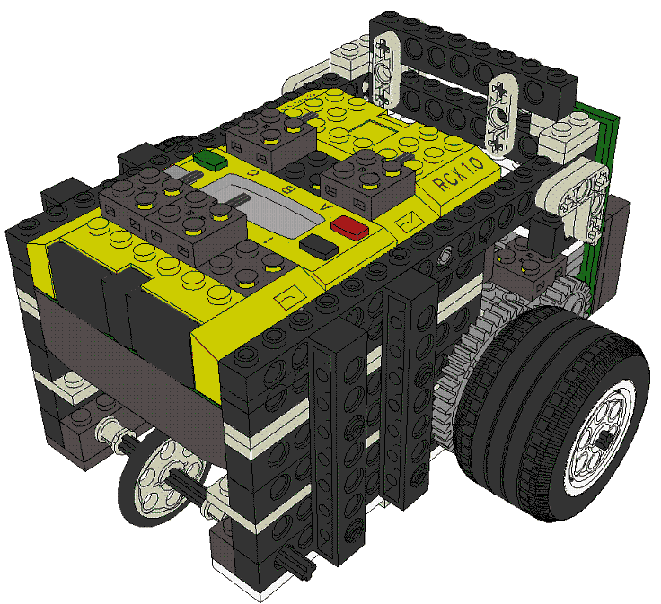

As a result, two wider wheels in conjunction with the motors and a third wheel for stability are used. In the final design, the robot has equal weight distribution and a lower center of mass thereby improving stability and turning accuracy.

Other preliminary design issues are the placement of the sensors and the frontal design of the robot. Although it may be intuitive to place the light sensor and touch sensor near the front of the robot, it becomes a challenge when incorporating the sensors at an optimal position, corresponding with the software design. According to the software implementation, the solution is to place the light sensor to the right of the robot so that it favours smooth turning and simultaneously aligns itself on the track. Additionally, the purpose of the touch sensor is to check whether or not the robot is pushing the second block. The frontal design uses two separate components to push the two distinct blocks. The initial mechanical structure below the touch sensor pushes the first block in the moat. Similarly, the other element is linked to the touch sensor is used to push the second block off the course. The touch sensor, positioned slightly above the first block, will not initiate when the robot pushes the first block into the mount.
The overall structure and mechanical parts of the design is located in the Appendix.

3.0 Software Design
In order to optimize the time spent on testing, the software design needs to be simple and concise. Since the obstacle course is not relatively complex, there is no benefit in writing difficult algorithms as long as it completes the objective. Consequently, the extra time spent on perfecting the mechanical design to suit the simple algorithm appeals to the general interest of the team.
There are three possible approaches to program the robot to move depending on the position of the light sensor. If the positioning of the light sensor is on the black starting line, then the code should use the path following method. Generally, this method is sluggish due to the excessive turning motion and the robot has to check whether it is on the line. Furthermore, the splitting path is difficult for the robot program to differentiate if the mechanical design is flawed. The second approach is to place the light sensor on the outer edge of the track. However, the problem with this software design is that the robot will only follow the more time consuming path. As a result, it makes most sense to place the light sensor on the inner edge of the track. This is the team’s main method of coding the robot’s movement and decision-making.
The following outlines the operation the team aims to achieve with the autonomous robot. From the initial point of the course, the state of the program is to move forward because the path starts in a straight line. Although the light sensor will enable the robot to distinguish the dark track and lighter outer areas, the value is relative to the brightness of light surrounding the robot. Therefore, an initial light sensor value reading is required to distinguish the track in both a well-lit or dim environment. After storing the temporary light sensing value, the robot will continue to move forward until the current light sensor value differ more than a set constant value when comparing the current light sensor value to the template light sensor value. Otherwise, the robot moves into the state of turning right until the robot is back on track. This method allows the robot to move smoothly without waste in movement while following the faster route. After that, the robot will cross the moat by pushing the block into it. In the final task, the robot will push the second block off the platform. By using the touch sensor and a timer when the sensor is pressed, the robot will be able push the block without falling off.
The state transition diagrams and flowcharts as well as the code for the software component are located in the Appendix.

4.0 Commissioning and Testing
The following are testing procedures that verify a new design concept.

4.1 Firmware Test
In order to confirm that the firmware is installed on the RCX, one must check the four zeros that appear on the RCX when it is on. Installing firmware onto the RCX Brick is essential to run the code.

4.2 Mechanical Component Test
After conceiving a design, it is necessary to complete the mechanical component before writing the program code. This procedure includes checking for structural weaknesses in the robot design or organization of its parts, which is vital to the project’s success. At times, it is necessary to change components and built them in a smarter, stronger way. The changes made to the mechanical design include the placement of the sensors, a new gear system and overall compact structure of the robot.

Table 1: Number of Successes and Failures for Various Motor Speeds
Sectional Trials |  | Speed of the Robot range from 1 (slowest) to 7 (fastest)
 |  | Speed 1 | Speed 2 | Speed 3 | Speed 4 | Speed 5 | Speed 6
First Turn | Success | 8 | 6 | 4 | 3 | 1 | 0
 | Failure | 2 | 2 | 4 | 5 | 3 | 4
Second Turn | Success | 6 | 5 | 4 | 2 | 0 | 0
 | Failure | 2 | 1 | 0 | 1 | 1 | 0
Push Block | Success | 5 | 4 | 3 | 1 | 0 | 0
 | Failure | 1 | 1 | 1 | 1 | 0 | 0
Cross Moat | Success | 5 | 4 | 3 | 1 | 0 | 0
 | Failure | 0 | 0 | 0 | 0 | 0 | 0
Push Block | Success | 5 | 4 | 3 | 0 | 0 | 0
 | Failure | 0 | 0 | 0 | 1 | 0 | 0
Stop | Success | 5 | 4 | 3 | 0 | 0 | 0
 | Failure | 0 | 0 | 0 | 0 | 0 | 0
Total attempts for the set speed |  | 10 | 8 | 8 | 8 | 4 | 4
Note at speed of seven is even faster than six meaning it will not successful, so it is not part of this table

From Table 1, it is evident that there is a correlation between the speed of the robot and the success of robot to completion the section of the track. At motor speeds greater than four, it becomes impractical to implement on the obstacle course.

4.3 Movement Test
After every mechanical design change, it is necessary to test the movement of the robot to ensure linear and turning motion are not factors that influence its performance in a particular area of the course. For instance, if the robot does not move in a straight line when coded to move forward, then there it will affect the overall performance of the robot. A separate program on the RCX tests the movement of the robot.

4.4 Sensor Tests
The light and touch sensor on the robot are essential for the robot to execute the correct states under specific conditions. Every time the placement of the sensor changes, it is important to test the sensors to verify the mechanical design to ensure execution efficiency. According to the mechanical and software design of the robot, the position of the light sensor is to the right of robot, which keeps the robot on the track. In addition, finding the constant light sensor value difference between the initial and current sensor reading is essential to the robot’s line following constancy. The method of debugging the sensors is through a series of test runs. During test runs, it is necessary to adjust the momentum of the robot during straightaways and turning speed to find the equilibrium between completion time and movement accuracy.

Table 2: Touch Sensor Testing Data
 | Approximate Distance Away from Edge of Table for three Ranges of Touch Sensor Values
Timer (in milliseconds) | Activate when sensor value less than 300 | Activate when sensor value less than 400 | Activate when sensor value less than 500
18 | Fails to push block off | Fails to push block off | Fails to push block off
20 | 3 cm | Fails to push block off | Fails to push block off
22 | 1.5 cm | 4 cm | Fails to push block off
24 | -0.5 cm | 2 cm | 4 cm
26 | -2 cm | 0 cm | 2.5 cm
28 | -4 cm | -2 cm | 2 cm
Note: a negative distance value indicates the distance the robot is off the edge of the course
According to Table 2, any values that are in the range of one centimetre to three centimetres are successful conditions of execution. It is safer to use a smaller value to trigger the touch sensor state because it ensures that the robot is pushing upon an object.
During the evaluation, the robot did not move in a straight line when the program gives instruction for it to do so. As a result, the robot failed to finish the obstacle course. The cause of the problem is unknown, but the team suspect it has to do with the RXC or low battery power.

5.0 Project Management
The following is an updated Gantt chart, which shows the actual timeline for the robotics project. The major difference between this chart and the preliminary Gantt chart is the longer construction completion time and code for the robot due to limited time. Moreover, the number of drastic changes made to the robot has gone beyond the initial estimation. In order to compensate for this change, it is necessary to shorten the time spent on optimization.

Figure 2: Robotics Project Actual Gantt chart for 2008
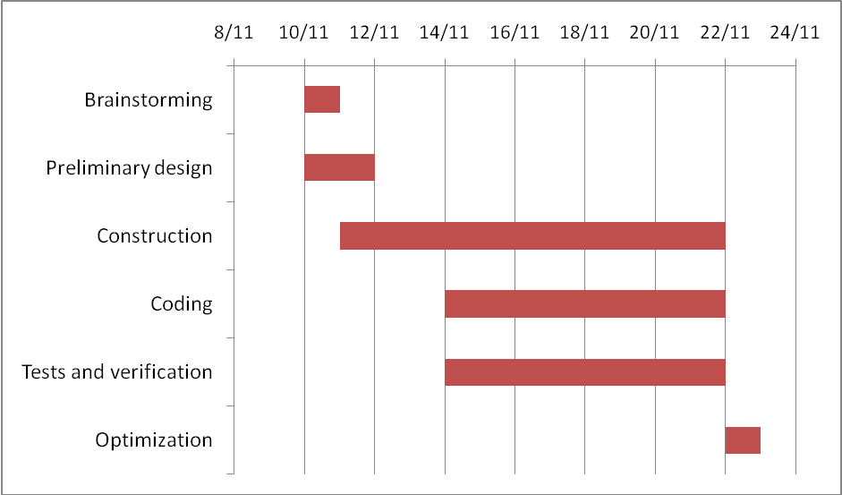

6.0 Assembly and Operation

6.1 Mechanical Assembly Instructions

Figure 3: Base Structure and Gear System
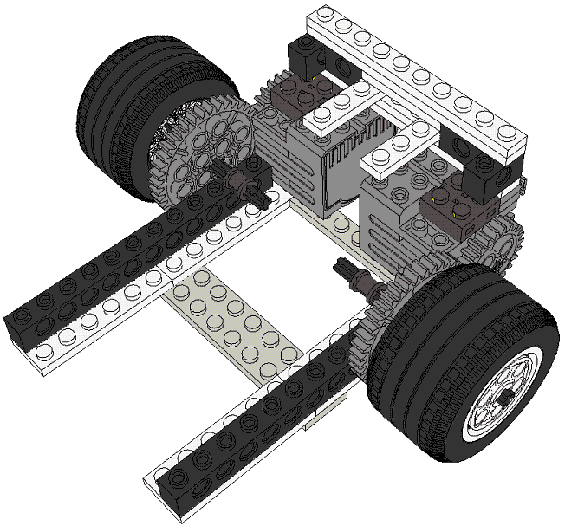

  - The 24-tooth gears are placed on the motors with the 40-tooth gear connected to the two 20 x 30 balloon medium wheels. Various plates (2x6, 1x4, and 1x10) hold the base structure in place as shown in the picture above.
  - A variety of bush pieces with holes and plates connects on either side to create two walls. At this point, the left and right side of the overall structure should still mirror each other. Refer to Figure 1 or Appendix A for more graphical representations of these steps.
  - Attach the electric Mindstorm RCX on the robot and secure it with pins. It is time to connect the wiring for the motors and sensors onto the RCX.
  - Construct the support structure for the touch sensor
  - Incorporate the light sensor to the right side of the robot

6.2 Software Details
In the software program, it is essential to initiate the sensors and motors values properly. According to the mechanical wiring of the sensor ports with the sensors and motors, the left motor is at port A, the right motor is at port C, the touch sensor is at port three and the light sensor is at port two. Please refer to the appendix for the wiring schematic and free hand sketches.

7.0 Conclusions
The effectiveness of the robot design will depend on the characteristics of the obstacle course. If the track is changed, the consistency of the robot’s ability to complete the course will also change. Although the mechanical design of the robot is robust and sturdy, the motors on the robot failed to align and move at coherent speeds during the day of evaluation. Therefore, the robot did not move in a straight line, which will ultimately influence the line following accuracy of the robot. Unfortunately, the robot failed to push the first block into the moat, so it cannot complete the final stretch of the course.

8.0 Recommendations
Incorporating an extra light sensor may increase the consistency of the robot following any given path in a more reliable manner. Some applications where the use of this robot may be appropriate after some slight modifications are the listed as follows:
- Survival finder where the robot may attempt to discover survivors in hard to reach places
- Explosives detector where it is safer to send an autonomous robot to investigate the scene
- Security robot where it surveys and monitors changes in the area

The success of the project is dependent on members’ teamwork, time management and commitment. This project is an example that displays the significance of the link between mechanical and software design. Next steps may involve striving towards the improvement of the robot’s effectiveness by adjusting the software design to match all types of tracks and the mechanical design to handle different types of terrain.
Including the extra lab sessions, there are four to five sessions to complete this project. However, the given amount of time is not sufficient. For future years, the project start date should be set earlier or more lab sessions be allocated. It is also important to consider the fact that group members cannot attend every lab session. As a result, there is a vast discrepancy for the work contributed by each member, which does not reflect in the grading. Therefore, it is necessary to use a log entry system. Each individual should document his or her work after every session. The various sections should be filled include the date, accomplishments, challenges, and future goals for the assignment. Finally, the idea of using CAD in the report is appealing but should not be included if time is limited.

Appendix A
Figure A: Final Assembled Robot in Lego CAD
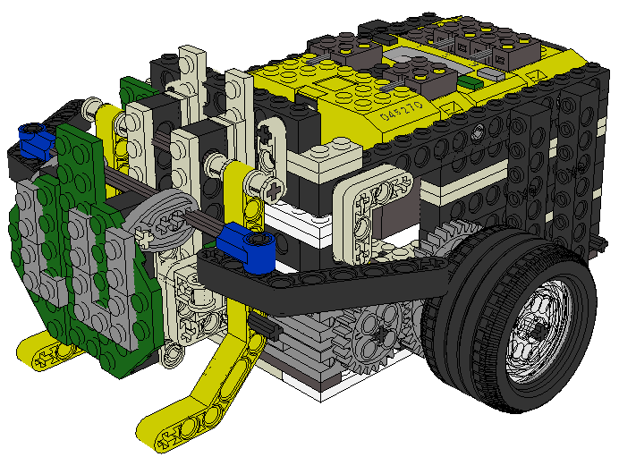
Figure B: Implementation of the Light Sensor and Touch Sensor
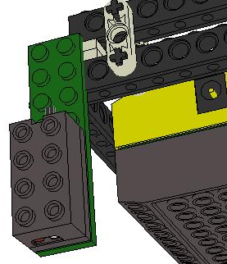 | 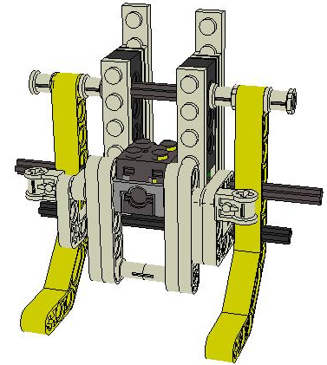
Note: On the left is the light sensor and the right is the touch sensor
Figure C: Final Program Code
// Macro substitution – easier to understand read the code
#define LeftWheel OUT_A // output for left motor
#define RightWheel OUT_C // output for right motor
#define BothWheels OUT_A+OUT_C // output for both motors
//==========================================================
// GLOBAL VARIABLES
int state = 0; // state of the robot
int White = 0; // light sensing variable for lower bound
int Black = 0; // light sensing variable for upper bound
// -------------- Set motor speed function ---------------
void setMotorSpeed(int LWPower, int RWPower) // sets the motor speed
{
SetPower(LeftWheel,LWPower); // left motor
SetPower(RightWheel,RWPower); // right motor
}

task main () // main program
{
// ---------- Configure sensors -------------
SetSensorType(SENSOR_3, SENSOR_TYPE_TOUCH); // touch sensor
SetSensorMode(SENSOR_3, SENSOR_MODE_RAW);
SetSensorType(SENSOR_2, SENSOR_TYPE_LIGHT); // light sensor
SetSensorMode(SENSOR_2, SENSOR_MODE_RAW);
White = SensorValue(1); // take initial reading on the white
int state = 1; // state set to forward
Black = White + 50; // calculate the sensor value black
do
{
setMotorSpeed(1,1); // calls the function set motor speed
if (SensorValue(2) <300) //Robot sensing Block
{
setMotorSpeed(6,6); // set motor speed to high power
SetDirection(LeftWheel ,OUT_REV); // move forward
SetDirection(RightWheel ,OUT_FWD);
SetOutput(BothWheels,OUT_ON);
Wait(22); // wait for 22 milliseconds

SetOutput(BothWheels,OUT_OFF); // stops before it falls off
break; // breaks out of loop and stops - DONE
}
else if (SensorValue(1) <= Black) // sensing white
{
state = 1; // state move forward
setMotorSpeed(7,7); // set motor speed
}
else if (SensorValue(1) >= Black) // while on black
{
state = 2; // state move right
setMotorSpeed(3,1); // set motor speed
}
// ---------------- Program States ----------------
switch (state)
{
case 1: // move forward
SetDirection(LeftWheel ,OUT_REV);
SetDirection(RightWheel ,OUT_FWD);
SetOutput(BothWheels,OUT_ON);
break;
case 2: // move to the right
SetDirection(LeftWheel,OUT_FWD);
SetDirection(RightWheel,OUT_FWD);
SetOutput(BothWheels,OUT_ON);
break;
}
}
while (true);
}

Figure D: Simple Program Flow Chart
Initialization of sensor values and variables

Touch Sensor pressed
Check touch sensor value

Finish execution

Delay
Touch Sensor not pressed
On White?
Make a Right Turn
Move Forward
On Black?

Note:
- Tthis method only works because the track only requires you to make right turns
- During the delay, the robot is moving forward at full speed while pushing the block

Figure E: List of Parts Used for Construction
Name of part | # of pieces used | Name of part | # of pieces used
T. Pin with Friction and Slots | 10 | T. Axle 2 | 4
Electric Mindstorms RCX | 1 | T. Brick 1 x 4 with Holes | 2
Electric Touch Sensor | 1 | T. Brick 1 x 2 with Hole | 4
T. Mini-Motor 9V | 2 | Plate 1 x 6 | 8
T. Wedge Belt Wheel Type | 1 | T. Bush | 10
T. Lift-arm 1 x 3 | 4 | T. Bush 1 x 16 with Holes | 2
T. Lift-arm 1 x 9 Bent | 2 | T. Bush 1 x 8 with Holes | 6
Tyre 49.6 x 228 VR | 2 | T. Gear 40 Tooth | 2
Wheel 20 x 30 Balloon Medium | 2 | T. Gear 24 Tooth | 2
T. Cam | 2 | Plate 1 x 8 | 2
T. Pole Reverser Handle | 2 | T. Brick 1 x 2 with Axle hole | 2
Brick 1 x 12 | 2 | Plate 1 x 2 with Door Rail | 4
Brick 2 x 2 x 2/3 Electric Wire End | 7 | T. Angle Connector #1 | 2
Plate 1 x 10 | 7 | T. Pin 3/4 | 4
T. Pin with Friction | 2 | T. Lift-arm 3 x 3 L Shape | 9
T. Wedge Belt Wheel | 3 | T. Lift-arm 1 x 5 | 4
Plate 2 x 10 | 4 | T. Lift-arm 1 x 11.5 Double Bent | 2
Plate 2 x 6 | 3 | Plate 2 x 8 | 2
T. Axle Pin | 6 | Plate 1 x 1 | 1
T. Brick 1 x 12 with Holes | 2 | Plate 1 x 2 | 5
T. Brick 1 x 6 with Holes | 2 | Electric Light Sensor | 1
T. Axle 10 | 3 | T. Brick 1 x 10 with Holes | 8
Plate 1 x 4 | 6 | Plate 2 x 12 | 2
T. Axle 12 | 2 | Plate 2 x 2 Corner | 5
T. Axle 8 | 2 | Plate 3 x 6 without Corners | 2
 |  | TOTAL | 175
NOTE: “T.” stands for Technic

Figure F: Free Hand Drawings

